ACHEMT Fall Symposium
Panel 1 - Healthcare Compliance: Emerging Trends and Best Practices for Managing Risk

Moderator

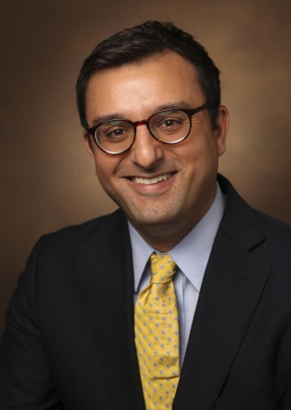

Steven Scutti, Esq., CHC
Compliance Officer
Vanderbilt University Medical Center

https://www.linkedin.com/in/steven-scutti-esq-chc-05954b61/

Steve currently serves as Vanderbilt University Medical Center’s Children’s Enterprise and Policy Governance Compliance Officer where he has been since 2019. Prior to VUMC, Steve previously worked in the Compliance Department at Children’s National in Washington, D.C., at the New Jersey Department of Health as an Attorney/Regulatory Officer representing the State of New Jersey at license revocation hearings and enforcement actions against long-term care facilities, and as a Special Deputy Attorney General in the NJ Division of Law representing the State of New Jersey in cases against banks, credit rating agencies, and mortgage servicing companies for their role in the subprime mortgage crisis. Prior to entering the workforce, Steve attended the University of South Carolina School of Law and Wake Forest University.

Panelist

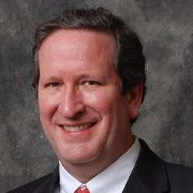

Andrew McDonald, FACHE
President/CEO
LBMC Physician Business Solutions

https://www.linkedin.com/in/admcdonaldfache/

Andrew McDonald, a former healthcare administrator (21 years) and consultant (18 years), works with a team of experienced health care professionals that possess diverse backgrounds and extensive experience in areas of Physician Practice Management, Compliance, Coding, Physician Compensation Modeling, Data Analytics, Payor contracting, practice IT solution selection/implementation, Revenue Cycle Management, Strategic Planning and Transaction Advisory Services. McDonald has assisted physicians establish multiple new medical practices and possess an in-depth knowledge of same. He works in concert with other areas within the firm to provide expertise and “real world” experience to augment the overall LBMC healthcare deliverable.

Panelist

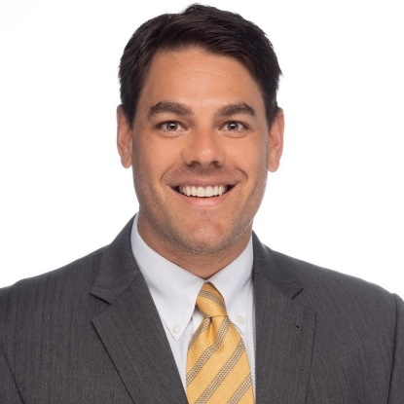

Elliott Durr, J.D., CHC
Ethics Compliance Officer
Tristar Centennial Medical Center

https://www.linkedin.com/in/elliott-durr-69874b17/

Elliott Durr is the Ethics and Compliance Officer at TriStar Centennial Medical Center. Elliott has worked in healthcare compliance field for the last 12 years. He specializes in operationalizing and educating on complex laws and regulations that govern the Healthcare industry. He received his undergraduate degree from Auburn University and his Juris Doctorate from Atlanta’s John Marshall Law School. Elliott is from Nashville and has 3-year-old twins that keep him busy away from work.

Panelist

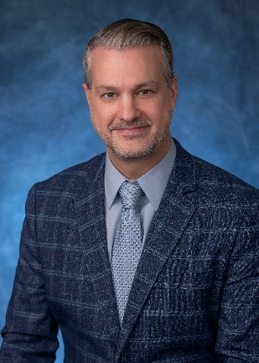

Mark Morrell, CHC, CCB
System Director and Senior Legal Counsel, Legal Compliance & Regulatory Affairs
CommonSpirit Health
https://www.linkedin.com/in/marktmorrell/

Mark Morrell is System Director, Senior Legal Counsel, at CommonSpirit Health, one of the nation’s largest nonprofit healthcare systems. For the past ten years, Mark has been working in-house at large healthcare companies, serving in legal and compliance roles. As in-house legal counsel, he has advised hospital operators, ambulatory surgery centers, and physicians about operational, compliance, and legal matters. Mark provides guidance about complex federal and state regulatory issues, internal investigations, compliance, Stark and Anti-Kickback advice, physician and medical staff matters, contract drafting, and day-to-day operational issues facing hospitals and other health care providers. He is admitted to practice law in Tennessee, Indiana, Virginia, and District of Columbia, and he holds a Certification in Healthcare (CHC) designation.

